Data Motion in the TRP Environment

Version 1.1
May 2011

Prepared by:
Michael Arndt
arndt@netapp.com

Abstract
This paper documents the steps for performing non-disruptive data migrations using NetApp Data Motion for vFilers in the Thomson Reuters Professional (TRP) environment.
TABLE OF CONTENTS

1 INTRODUCTION 3
1.1 Conventions 3
1.2 Requirements and supported configurations 4
2 Initiating a migration with Data Motion for vFilers 5
2.1 Starting a migration 5
2.2 Choosing the migration type 6
2.3 Choosing the destination storage system 6
2.4 Modifying the aggregate mappings 7
2.5 Configuring the network bindings 7
2.6 Specifying a transfer throttle 9
2.7 Choosing the cutover type 10
2.8 Final steps of migration initialization 10
2.9 DFM alert when performing baseline data transfer 12
2.10 Updating the snapmirror.conf settings on the destination storage system 13
3 Performing the cutover 14
3.1 Checking the status of the data transfers and initializing the final cutover 14
3.2 The script path option 15
3.4 Network routes 15
3.5 Cutover summary screen 16
3.6 Finalizing the cutover 16
3.7 Troubleshooting a failed cutover attempt 18
4 Cleanup work 19
4.1 Cleaning up the source vFiler flexvols 19
4.2 Cleaning up SnapMirror related snapshots 20
4.3 Correcting the dataset physical properties 20
5 Resources 21

1 INTRODUCTION
This paper documents the steps for performing non-disruptive data migrations using NetApp Data Motion for vFilers in the Thomson Reuters Professional (TRP) environment. This document assumes that the reader is familiar with basic NetApp storage management concepts such as vFilers, aggregates, flexible volumes (volumes, or flexvols), and SnapMirror.

1.1 Conventions
The following conventions are used throughout this document:
NMC -> list-> list
The convention above indicates a list of links to click on in order to accomplish a task using the Provisioning Manager interface in the Network Management Console.
netapp>
The convention above indicates a command to run on a NetApp storage system.
dfm>
The convention above indicates a command to run on a DFM server.

1.2 Requirements and supported configurations
Online Data Motion for vFilers requirements:
Data OnTap 7.3.3P3 or higher with the multistore, snapmirror, and snapmirror_sync licenses (KZZTWOJ).
- Provisioning Manager 4.0D15 or higher.
- Data configured in the Multistore (vFiler) model.

Online Data Motion for vFilers supported configurations:
- Between clustered storage systems only:
  - No movement between controllers in the same cluster.
  - No movement between aggregates on the same controller.
  - No movement between single controller systems.
- From equal or less powerful to more powerful clusters - examples:
  - Movement from FAS6080 to FAS6080 cluster is OK.
  - Movement from FAS3140 to FAS3140 cluster is OK.
  - Movement from FAS3140 to FAS6080 cluster is OK.
  - Movement from FAS6080 to FAS3140 cluster is not currently allowed.
- For data in vFilers accessed via NFS or iSCSI only:
  - Any data accessed via CIFS will experience a disruption
- During low utilization periods of activity on the storage systems.
  - Provisioning Manager will warn you if system utilization is too high.
  - CPU utilization must be below 90% on each storage system regardless of the workload on the vFiler being migrated.
  - How far below 90% the CPU utilization must be depends on the workload of the source and destination storage systems, as well as the workload on the vFiler being migrated.
- During normal system operation:
  - Neither the source nor the destination can be in takeover mode
- Maximum number of flexvols per vFiler:
  - FAS3xxx – maximum of 8 flexvols per vFiler.
  - FAS6xxx – maximum of 20 flexvols per vFiler.
- Other requirements and limitations:
  - vFilers to be migrated must own entire flexvols, not qtrees.
  - Identically named IpSpaces must exist on the source and destination storage systems.
  - All flexvols must be 10GB in size or larger. Provisioning Manager will automatically resize vFiler root flexvol before and after the migration process to meet this requirement.
  - Deduplicated flexvols will have their fingerprint DB recreated after a migration with the netapp> sis start –s command.
  - If iSCSI is enabled on the vFiler, the iscsi.ip_based_tpgroup option must be on.

TRP environment configuration requirements:
- A 1GbE or faster network interface on the TRP management network for the storage system.
- Working DNS resolution for both the simple hostname and FQDN of the source and destination storage systems. This can be tested using the “ping” command on the storage systems.
- If there are “nosnap” volumes being migrated, create a 10% snap reserve for these volumes, increasing the size of the volume as needed. This is required in order for SnapMirror snapshots to be used during the migration process, in conjunction with snap autodelete being in place. The snap reserve can be set back to 0 and volume resized when the migration is finished.

2 Initiating a migration with Data Motion for vFilers
In the contents of this section, we show the steps for initiating a migration with Data Motion for vFilers.

2.1 Starting a migration
To start a migration, go to NMC->ProvMgr->Hosts->vFiler Units, select the vFiler that you wish to migrate, and click on Start migration per the following screenshot:

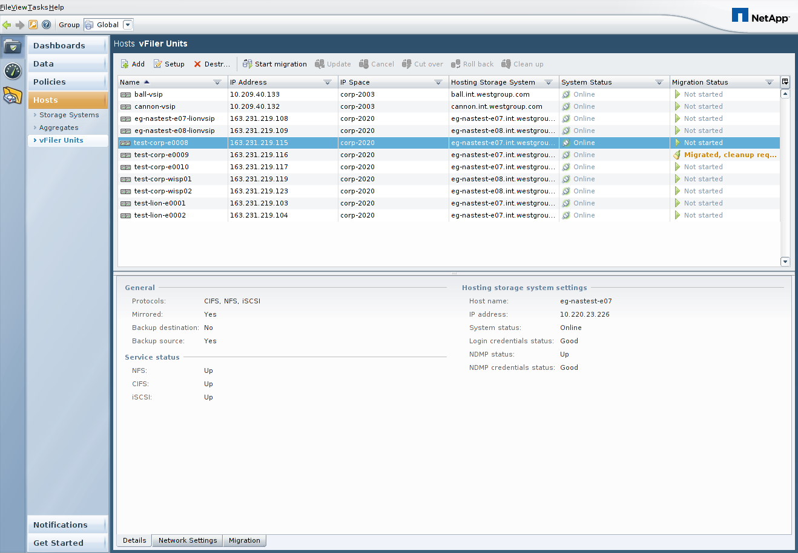

After you click on Start migration, a migration wizard will walk you through the required steps, as we will document in the remainder of section 2.

2.2 Choosing the migration type
The first step is to choose the type of migration you wish to initiate, per the following screenshot. In most cases, you should select Online migration, assuming you want to move a vFiler and it’s data from one storage system to another non-disruptively.

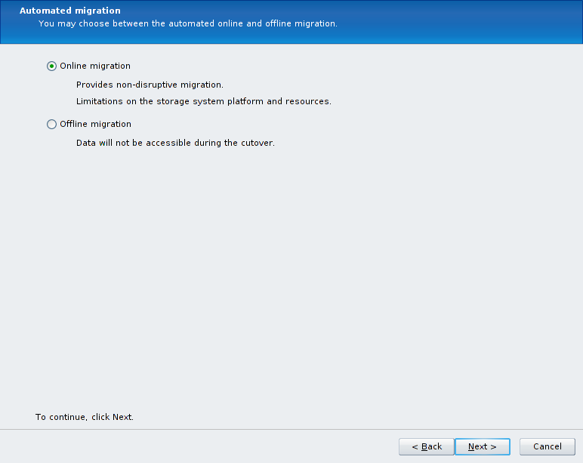

2.3 Choosing the destination storage system
In the next screen, choose the destination storage system. Reference the rules around Data Motion for vFilers as described in section 1.2 to determine the requirements for the destination system.

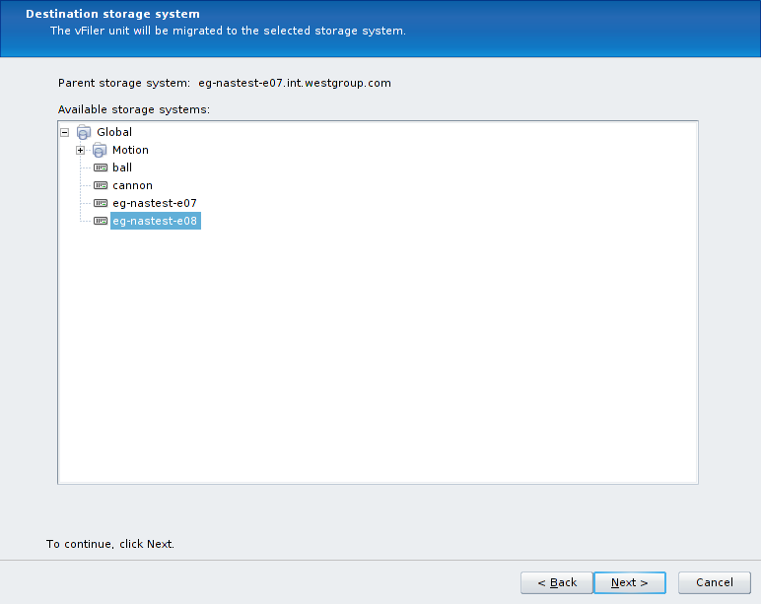

2.4 Modifying the aggregate mappings
If you wish to specify the exact destination storage system aggregate on which the flexvols for the vFiler will be placed, click on the Customize the volume to aggregate mappings checkbox as shown in the screenshot below. Then select each Source volume, select a Destination aggregate from the dropdown box, and hit the Apply button. This must be done for each source flexvol. If you choose not to customize the flexvol to aggregate mappings, Provisioning Manager will automatically select the destination aggregate with the most free space.

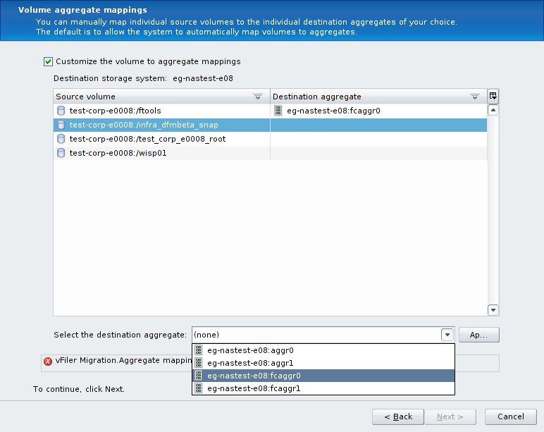

2.5 Configuring the network bindings
On the Network interface settings page, select the IP address of the vFiler and click on Edit:

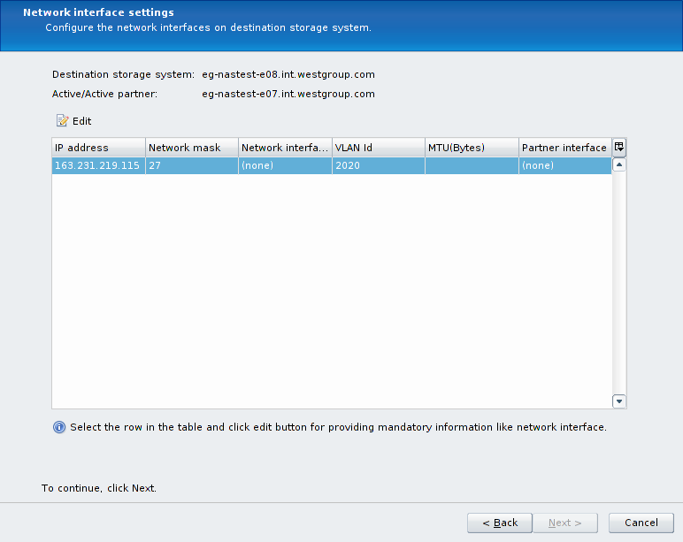

The first screen you will see when editing the network bindings will look something like the following screenshot. Note that the Network interface is set to (none) and the VLAN Id has a value.

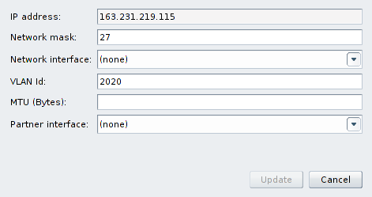

The items we need to modify in this form are the Network interface and the VLAN Id. The VLAN Id is pre-populated with the VLAN tag number, in preparation for creating a new VLAN tagged interface on the destination storage system. However, in the TRP environment, all of our VLAN tagged interfaces are pre-created, so we can simply remove this value as shown in the next screenshot. It is useful to use this VLAN tag number to find the corresponding interface to use in the Network interface list, as is also shown below:

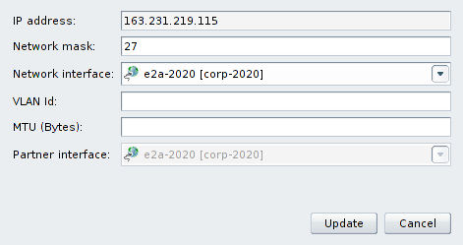

Note that it is not necessary to specify the MTU setting, nor is it necessary to modify the Network mask settings, and the Partner interface setting will be configured automatically. Once these changes are made, click on the Update button.

After clicking on the Update button, the Network interface settings screen will look similar to the following screenshot, and you can click on Next to continue.

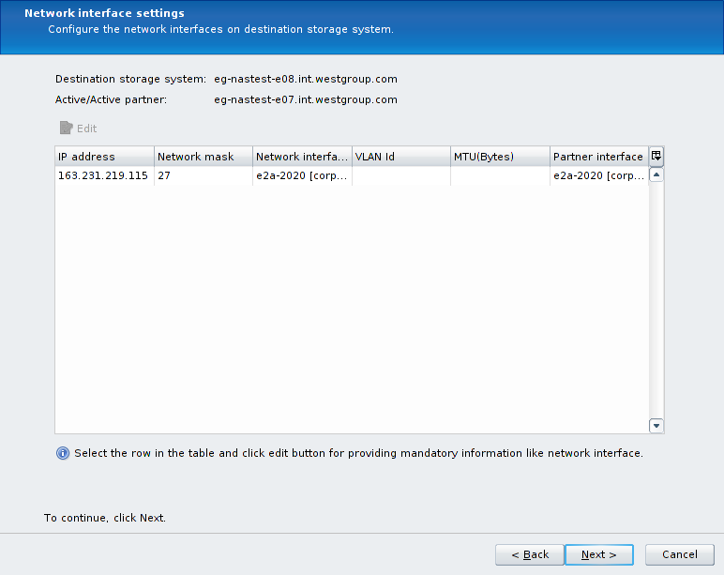

2.6 Specifying a transfer throttle
If you wish to specify a transfer throttle to limit the amount of network bandwidth used during the baseline SnapMirror data transfers, you may do so now. It should be noted that Data Motion for vFilers will use the TRP management interfaces (a non-vFiler IP address must be used) for SnapMirror traffic, which are 1GbE interfaces. Because of this, we will most likely not need to use a transfer throttle.

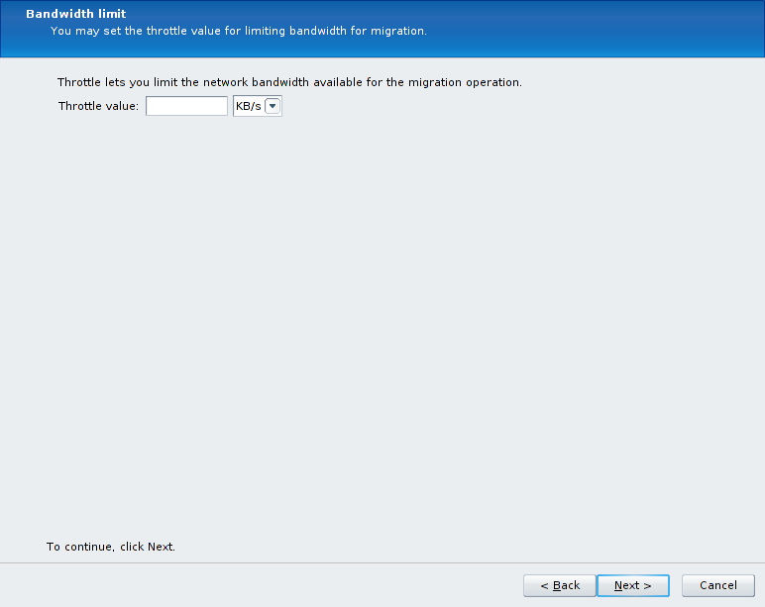

2.7 Choosing the cutover type
You can choose to have Provisioning Manager automatically perform the final cutover after the baseline data transfers are done, but we will typically like to perform the cutover during a controlled change window in the TRP environment. Therefore, this option will typically be left unchecked.

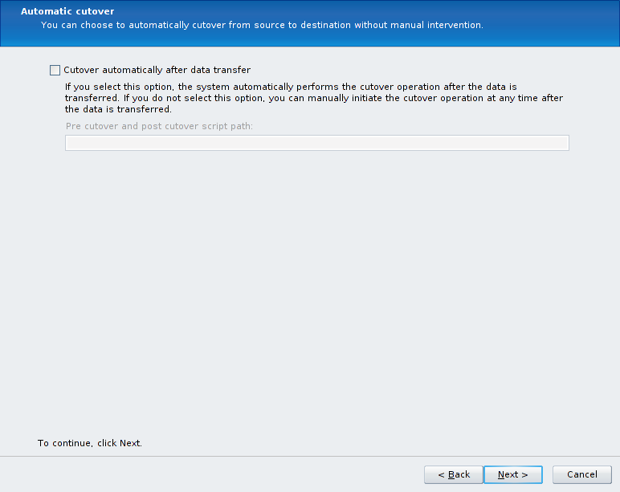

2.8 Final steps of migration initialization
The Preview screen will show you a summary of the steps that Provisioning Manager is about to perform. There should be no errors or warning on this summary screen.

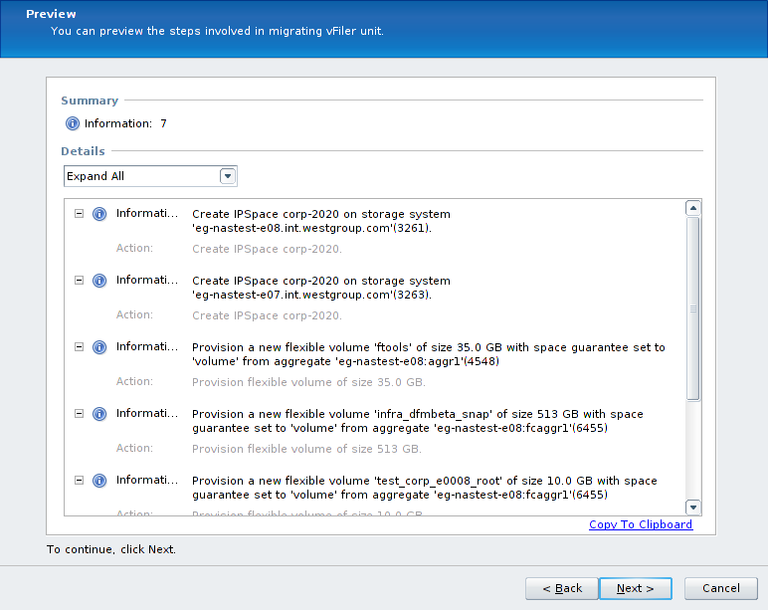

There is one final screen to hit Finish on in order to initiate the baseline data transfers:

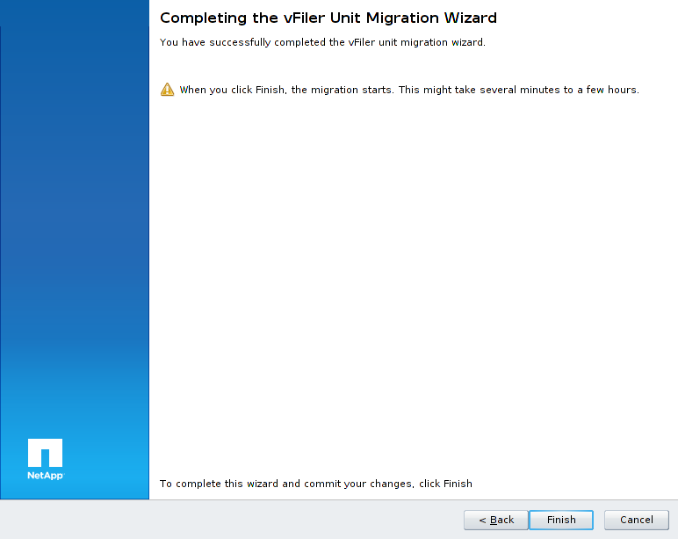

After hitting the Finish button, a task window is displayed that shows the progress as the flexvols are configured on the destination storage system:

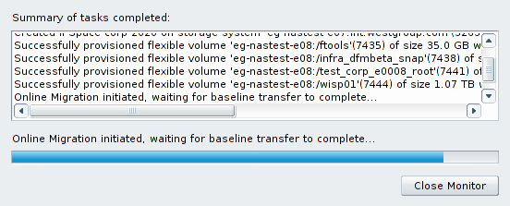

The main NMC interface will look similar to the following screenshot while the baseline data transfer is in progress:

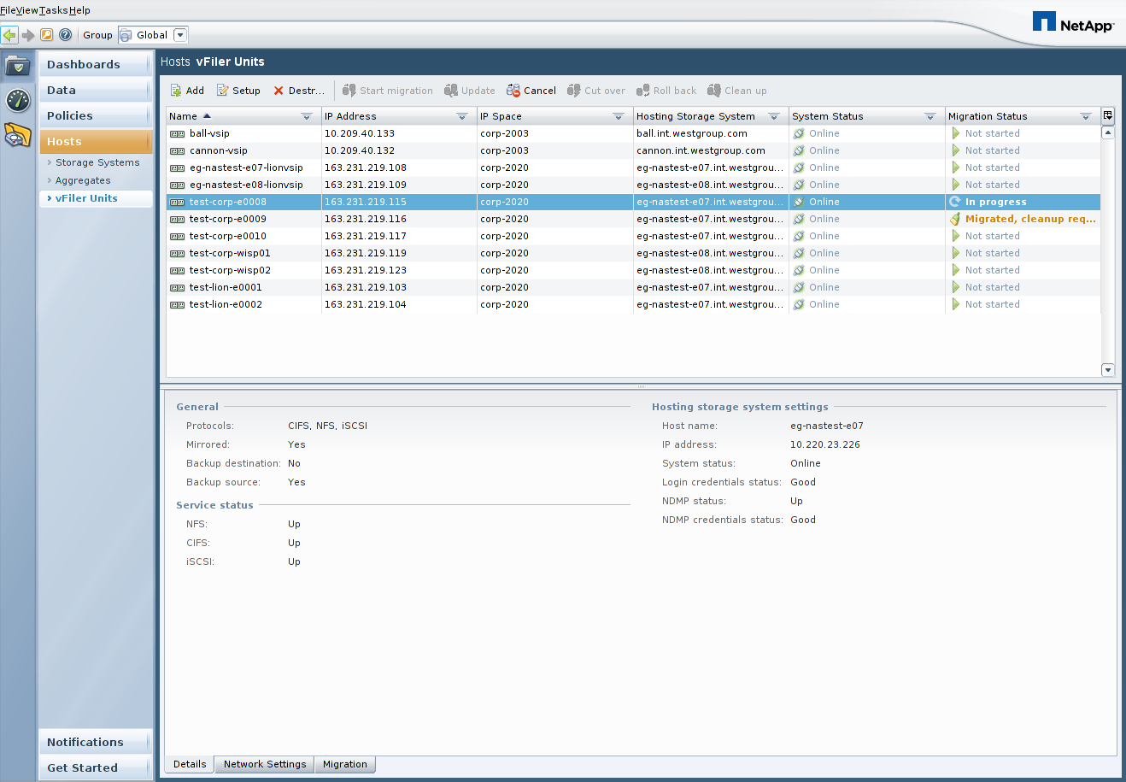

2.9 DFM alert when performing baseline data transfer
When the baseline data transfer is started, an offline vFiler is created on the destination storage system with the same name as the vFiler to be migrated. This will cause a DFM alert to be generated about this vFiler being offline, which can be safely ignored.

2.10 Updating the snapmirror.conf settings on the destination storage system
Due to NetApp bug 499156, the snapmirror.conf schedule that is put in place on the destination storage system is incorrect in that it uses - characters instead of * characters in the last 3 fields of the schedule. In addition, the default schedule has more frequent updates than is required.

The recommendation for the TRP environment is to change the SnapMirror update schedules in /etc/snapmirror.conf on the destination storage system as shown in the following example:

Original /etc/snapmirror.conf entry:
srcfiler:srcvol dstfiler:dstvol – 0-59/3 - - -

Recommended /etc/snapmirror.conf entry:
srcfiler:srcvol dstfiler:dstvol – 15,45 * * *

This change should be made by manually editing the /etc/snapmirror.conf file with a unix based text editor such as VI, or using Wordpad (not Notepad) from a Windows client. The change will need to be made for all volumes involved in the DataMotion migration.

3 Performing the cutover

3.1 Checking the status of the data transfers and initializing the final cutover
While the baseline data transfer is in progress, you can check the status of the transfers by running the netapp> snapmirror status command on either the source or destination storage system. When the baseline data transfer is complete, the snapmirror status output will say idle for the flexvols involved in your Data Motion for vFilers migration, and the Provisioning Manager screen will report a Migration Status of Started, cutover required as shown in the following screenshot.

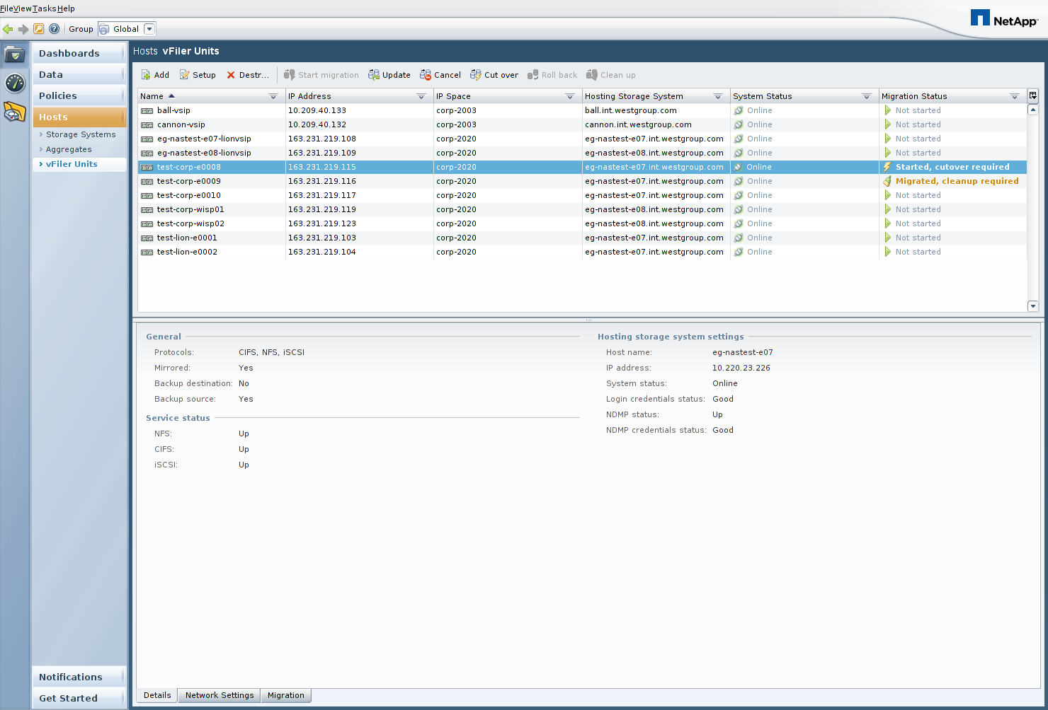

When you are ready to perform the final cutover, click on the Cut over button as shown above to initiate the final cutover process.

3.2 The script path option
The first screen in the Cut over wizard provides an option to run a script before and after the final cutover. This can be left blank in the TRP environment.

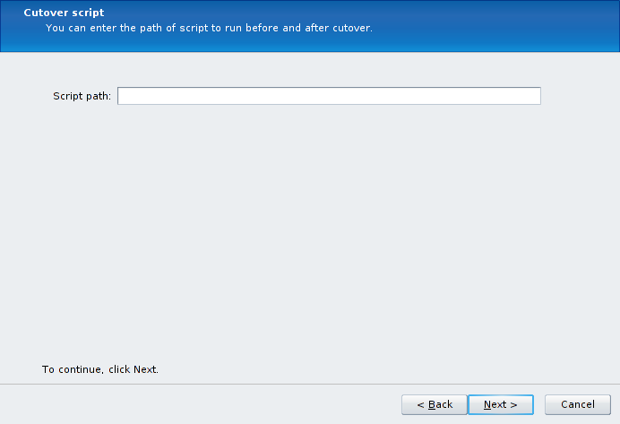

3.4 Network routes
The next screen allows you to specify which network routes will get migrated to the destination storage system. In the TRP environment, all of our default routes are held by the VSIP vFilers, so you should click on the Do not migrate any routes radio button.

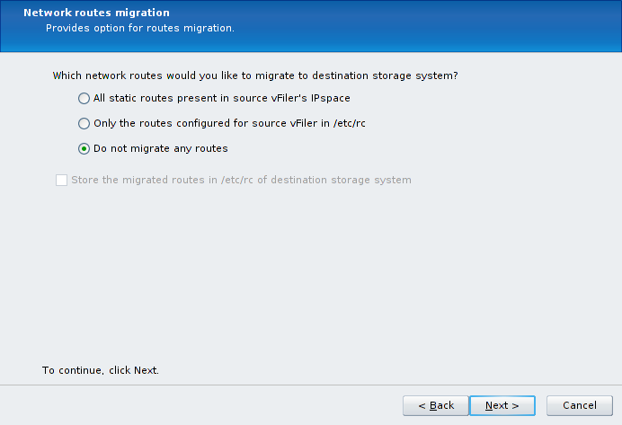

3.5 Cutover summary screen
In the Preview screen, you should expect to see a Warning that Provisioning Manager will be Resizing the root volume of the vFiler. This is to be expected, as 10GB is the minimum flexvol size for semi-synchronous SnapMirror relationships.

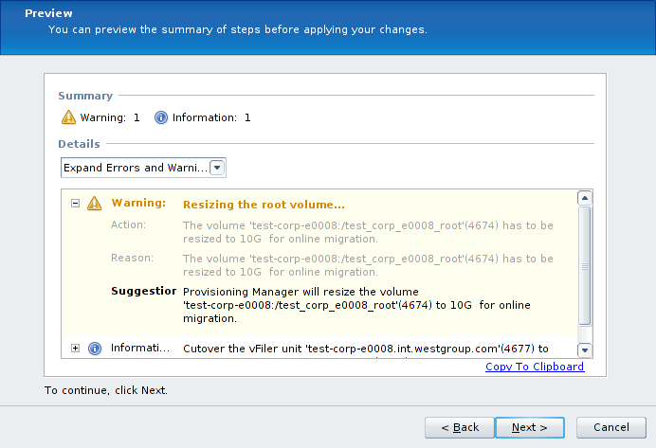

3.6 Finalizing the cutover
When you click on Finish in the following screenshot, the final migration cutover will begin.

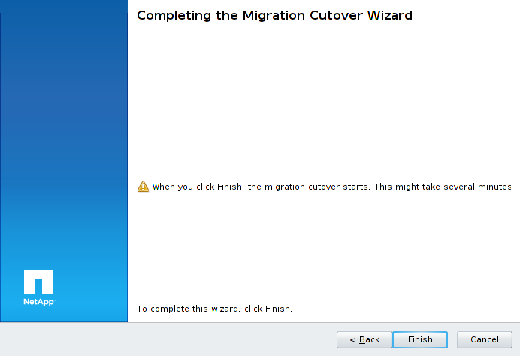

The screenshots on the following page will show what to expect during the final cutover process. Keep in mind that the final cutover process may take up to 30 minutes to complete as final synchronizations are configured, but the actual I/O pause during the final cutover will last less than 120 seconds.

First, the root flexvol is resized and the SnapMirror relationships are configured in semi-synchronous mode:

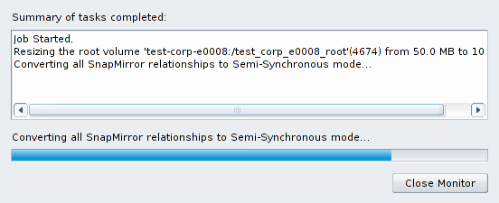

Once semi-synchronous mode is achieved, the vFiler is migrated:

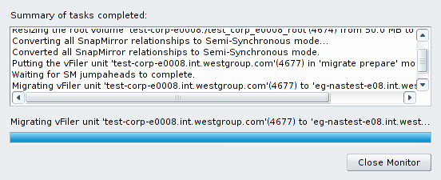

You will see a vFiler unit <vfilername> successfully migrated message when the migration is complete:

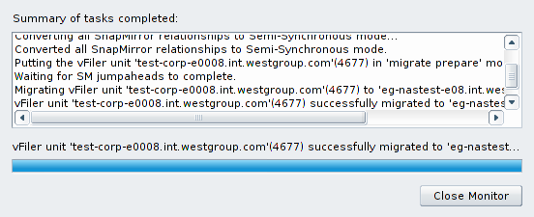

Back in the NMC interface, the Migration Status for this vFiler unit will show Migrated, cleanup required:

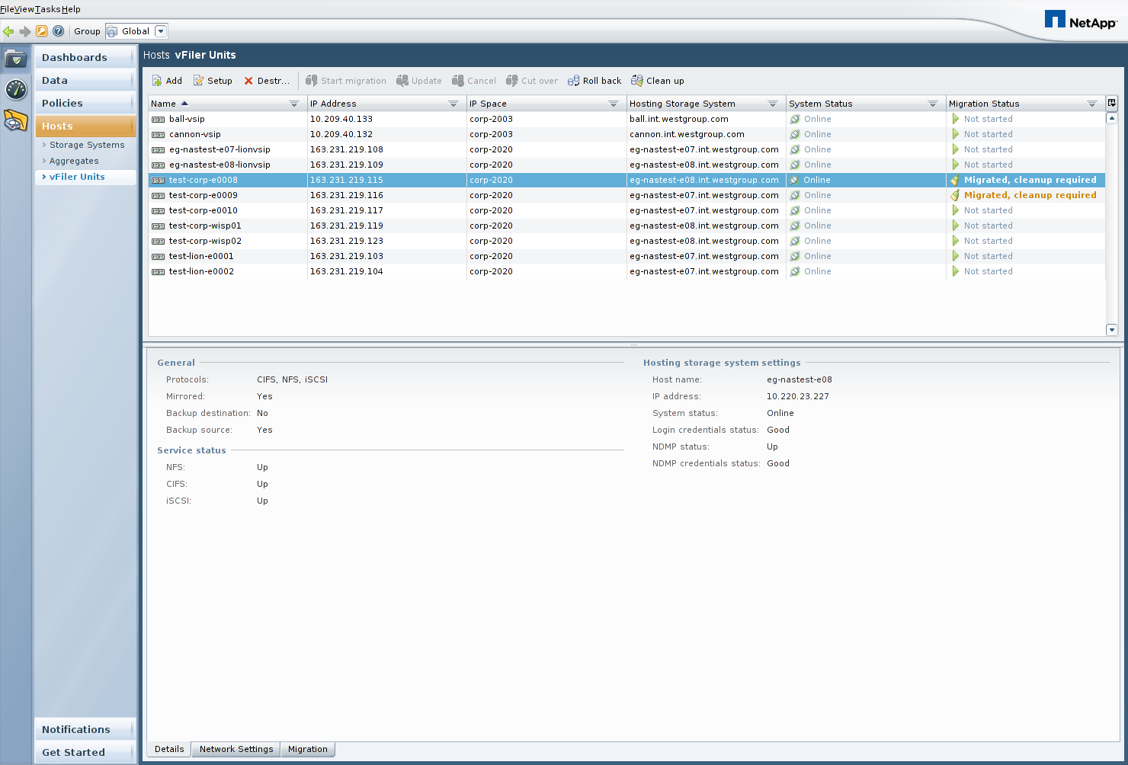

In the next section, we will discuss the required cleanup work.

3.7 Troubleshooting a failed cutover attempt
If the cutover attempt fails, the vFiler will continue running on the original source storage system. In order to determine why a cutover failed, it may be necessary to look at the contents of the datamotion.log file in the log directory of the DFM server. In the TRP environment, this is at /dfm/dfminst/log/datamotion.log on all DFM servers. It is recommended to monitor the messages in this log file in real time during the cutover, in order to verify that things are proceeding as expected and to help quickly troubleshoot any problems. This can be done with the following command on the DFM server:

dfm> tail –f /dfm/dfminst/log/datamotion.log
4 Cleanup work

4.1 Cleaning up the source vFiler flexvols
If for some reason you need to put the vFiler back on the original source system shortly after the cutover, the Provisioning Manager interface has a Roll back button that can be used to do so without requiring a re-baseline data transfer. Use of this feature will launch a wizard interface similar to the Cut over wizard, and it will resync the SnapMirror relationships in the opposite direction prior to performing a cutover to put the vFiler back in place on the original source storage system.

If you are sure that no Roll back will be required, you can then use the Provisioning Manager interface to destroy the flexvols related to the migrated vFiler from the source storage system, using the Clean up button as shown in the screenshot below:

Once this Provisioning Manager Clean up task completes, there are two more steps required to complete the all necessary cleanup work for the TRP environment, as detailed in the next two sections.

4.2 Cleaning up SnapMirror related snapshots
The Provisioning Manager interface does not remove the flexvol snapshots created by the SnapMirror process. SnapMirror flexvol snapshots will exist on the flexvols owned by the migrated vFiler on the destination storage system, and they will be in the following format:

dest_filer(sysid)_name.number

- dest_filer is the host name of the destination filer.
- sysid is the destination system ID number.
- name is the name of the destination flexvol.
- number is the number of successful transfers for the Snapshot copy, starting at 1. Data ONTAP increments this number for each transfer.

You can use the Data ONTAP CLI, FilerView, or Provisioning Manager to remove the snapshots in this format from all flexvols owned by the migrated vFiler.

4.3 Correcting the dataset physical properties
After a vFiler is migrated from one physical storage system to another, the Provisioning Manager datasets related to the vFiler must be updated to reflect the new resource pool in use. This is required because resource pools are logical constructs that could span many storage systems, and as such Provisioning Manager has no way of knowing that in the TRP environment we define one resource pool per physical storage system. To correct the resource pool configuration, go to the following section of the Provisioning Manager interface for each dataset (flexvol) owned by the migrated vFiler:

NMC->Provisioning Manager->Data->Datasets-><select dataset>->Edit->Provisioning/Resource Pools->Resource Pools

This section of Provisioning Manager will allow you to remove the old physical storage system resource pool and add the new physical storage system resource pool for the dataset.

5 Resources

Provisioning Manager Administration Guide:
https://now.netapp.com/NOW/knowledge/docs/DFM_win/rel40/html/software/workflow/frameset.html

Data Motion Technical Report
http://media.netapp.com/documents/tr-3814.pdf

